User’s Manual

App Layout:

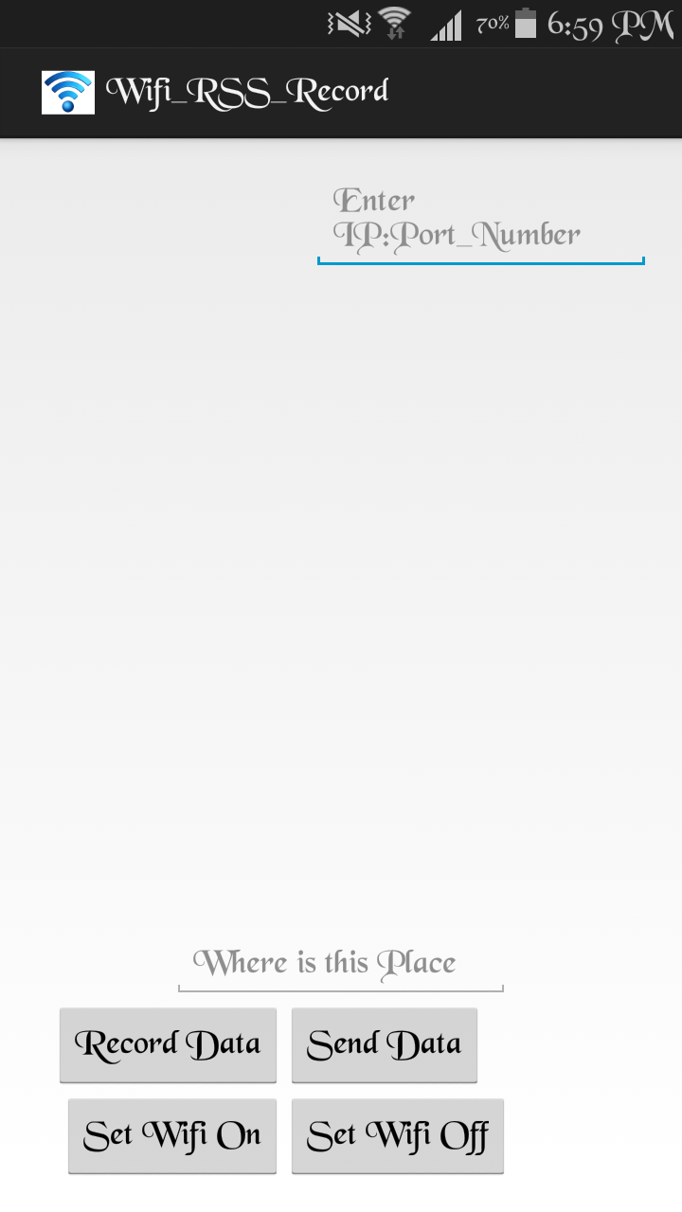
IP Address and port number of Server

4. Button to Send recorded data to the Server

Name of the location
3. Button to record the RSS data

1. Button to turn “ON” Wi-Fi

2. Button to turn “OFF” Wi-Fi

1. Turning Wi-Fi “ON” and “OFF”

- Click on Button 1 to turn on Wi-Fi of the device.

- Click on Button 2 to turn off Wi-Fi of the device.

2. Enter the name of location where the data is recorded

Enter the name of the location (without any space in between) where the data is data is recorded for in the text box which shows “Where is this place”.

3. Record RSS Data

Make sure the Wi-Fi of the device is switched ON.

Click on Button 3 to record the RSS values received from the four specific routers (data is recorded for 300 seconds) with MAC Addresses:

- 00:26:3e:f5:9a:c2
- 00:26:3e:f5:9a:c0
- 00:26:3e:f5:9a:c4
- 4c:60:de:fc:2e:9c

Probability for each RSS value is calculated automatically and stored in an xml format.

4. Enter the IP Address and Port Number of the server

Enter the IP v4 Address of the computer where the server program is running and the port number, which the server program is listening to, separated by a colon, in the text box on the top right corner of the screen.
Format:
<IP Address>:<Port number>

5. Send Recorded data

Click on Button 4 to send the data in the xml format to the server program that is running on the server. Make sure that the IP Address and port number of the server is entered correctly and the server program is running properly on the server side.

